Old Warren Primary School
Code of Conduct

Approved by Board of Governors:
Chairperson:
Date:
Date of Review:
Old Warren Primary School
Code of Conduct for Staff and Volunteers in

Schools

Objective, Scope and Principles
This Code of Conduct is designed to give clear guidance on the standards of behaviour all school staff and volunteers are expected to observe. School staff and volunteers are role models and are in a unique position of influence and trust and must adhere to behaviour that sets a good example to all the pupils/students within the school. As a member of a school community, each person has an individual responsibility to maintain their reputation and the reputation of the school, whether inside or outside working hours.
This Code of Conduct applies to all staff and volunteers of the school.
This Code of Conduct does not form part of any employees' contract of employment.

l. Setting an Example

1.1 All staff and volunteers who work in schools set examples of behaviour and conduct which can be copied by pupils/students. Staff must therefore for example avoid using inappropriate or offensive language at all times.
1.2 All staff and volunteers must, therefore, demonstrate high standards of conduct in order to encourage our pupils/students to do the same.
1.3 All staff and volunteers must also avoid putting themselves at risk of allegations of abusive or unprofessional conduct.
1.4 This Code helps all staff and volunteers to understand what behaviour is and is not acceptable and regard should also be given to the disciplinary rules set out by the employing authority.
1.5 All staff and volunteers are expected to familiarise themselves and comply with all school policies and procedures.

2. Safeguarding Pupils/Students
2.1 All staff and volunteers have a duty to safeguard pupils/students from physical abuse, sexual abuse, emotional abuse, neglect and exploitation.
2.2 The duty to safeguard pupils/students includes the duty to report concerns about a pupil/student or colleague to a member of the school's Safeguarding team (Designated Teacher (DT)/Deputy Designated Teacher (DDT) for Child Protection or the Principal).
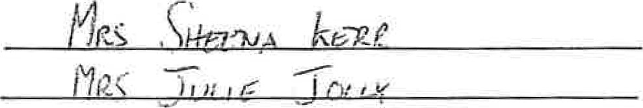
2.3 The school's DT is(Name) and the DDT is(Name)
2.4 All staff and volunteers are provided with personal copies of the school's Child Protection Policy and Whistleblowing Policy and must be familiar with these documents and other relevant school policies eg e-Safety and Acceptable Use Policy.
2.5 All staff and volunteers should treat children with respect and dignity. They must not demean or undermine pupils, their parents, carers or colleagues.
2.6 All staff and volunteers should not demonstrate behaviours that may be perceived as sarcasm, making jokes at the expense of students, embarrassing or humiliating students, discriminating against or favouring students.
2.7 All staff and volunteers must take reasonable care of pupils/students under their supervision with the aim of ensuring their safety and welfare. Staff should also complete risk assessments where appropriate in accordance with school policies.

3. Relationships with Students
3.1 All staff and volunteers must declare any relationships that they may have with pupils/students outside of school; this may include mutual membership of social groups, tutoring, or family connections. Staff and volunteers should not assume that the school are aware of any such connections. A declaration form may be found in Appendix 1 of this document.
3.2 Relationships with students must be professional at all times, sexual relationships with students are not permitted and may lead to an abuse of trust and criminal conviction.

4 Pupil Student Development

4.1 All staff and volunteers must comply with school policies and procedures that support the well-being and development of pupils/students.

4.2 All staff and volunteers must co-operate and collaborate with colleagues and with external agencies where necessary to support the development of pupils/ students.

5. Honesty and Integrity

5.1 All staff and volunteers must maintain high standards of honesty and integrity in their work. This includes the handling and claiming of money and the use of school property and facilities.

5.2 Gifts from suppliers or associates of the school must be declared to the Principal with the exception of “one off” token gifts from students or parents. Personal gifts from individual members of staff or volunteers to students are inappropriate and could be misinterpreted and may lead to disciplinary action. A record will be kept of all gifts received.

6. Conduct Outside of Work

6.1 All staff and volunteers must not engage in conduct outside work which could seriously damage the reputation and standing of the school or the staff/ volunteers own reputation or the reputation of other members of the school community.

6.2 In particular, criminal offences that involve violence, possession or use of illegal drugs or sexual misconduct are to be regarded as unacceptable.

6.3 Staff may undertake work outside school, either paid or voluntary, provided that it does not conflict with the interests of the school. It should not contravene the working time regulations or affect an individual’s work performance in the school. Staff should seek advice from the Principal when considering work outside the school.

7. E-Safety and Internet Use

7.1 Staff must exercise caution when using information technology and be aware of the risks to themselves and others. Regard should be given to the schools’ E-Safety and ICT Acceptable Use Policy at all times both inside and outside of work.

7.2 Staff and volunteers must not engage in inappropriate use of social network sites which may bring themselves, the school, school community or employer into disrepute. Staff and volunteers should ensure that they adopt suitably high security settings on any personal profiles they may have.
7.3 Staff should exercise caution in their use of all social media or any other web based presence that they may have, including written content, videos or photographs, and views expressed either directly or by 'liking' certain pages or posts established by others. This may also include the use of dating websites where staff could encounter students either with their own profile or acting covertly.
7.4 Contact with students must be via school authorised mechanisms. At no time should personal telephone numbers, email addresses or communication routes via personal accounts on social media platforms be used to communicate with students. If contacted by a student by an inappropriate route, staff should report the contact to the Principal immediately.
7.5 Photographs/stills or video footage of students should only be taken using school equipment for purposes authorjsed by the school. Any such use should always be transparent and only occur where parental consent has been given. The resultant files from such recording or taking of photographs must be retained and destroyed in accordance with the schools Records Management Policy and Disposal Schedules.

8. Confidentiality
8.1 Members of staff and volunteers may have access to confidential information about students in order to undertake their everyday responsibilities. In some circumstances staff may be given additional highly sensitive or private information. They should never use confidential or personal information about a student or his family for their own, or others' advantage. Information must never be used to intimidate, humiliate, or embarrass the student.
8.2 Confidential information about students should never be used casually in conversation or shared with any person other than on a “need to know” basis. In circumstances where the student's identity does not need to be disclosed the information should be used anonymously.
8.3 There are some circumstances in which a member of staff may be expected to share information about a student, for example when abuse is alleged or suspected. In such cases, individuals have a duty to pass information on without delay, but only to those with designated child protection responsibilities.
8.4 If a member of staff is in any doubt about whether to share information or keep it confidential he or she should seek guidance from a senior member of staff. Any media or legal enquiries should be passed to senior leadership.
8.5 Adults need to be aware that although it is important to listen to and support students, they must not promise confidentiality or request students to do the same under any circumstances.
8.6 Additionally concerns and allegations about adults should be treated as confidential and passed to a senior leader without delay.

9. Dress and Appearance
9.1 All staff and volunteers must dress in a manner that is appropriate to a professional role and promoting a professional image.
9.2 Staff and volunteers should dress in a manner that is not offensive, revealing or sexually provocative.
9.3 Staff and volunteers should dress in a manner that is absent from political or other contentious slogans.

10. Disciplinary Action
Staff and volunteers should be aware that a failure to comply with this Code of Conduct could result in disciplinary action including but not limited to dismissal.

11. Compliance
All staff and volunteers must complete the form in Appendix 2 to confirm they have read, understood and agreed to comply with the code of conduct. This form should then be signed and dated.

Appendix 1

Relationships with Students Outside of Work Declaration
It is recognised that there may be circumstances whereby staff and volunteers of the school are known to students outside of work. Examples include membership of sports clubs, family connections, or private tutoring.
Staff must declare any relationship outside of school that they may have with students.
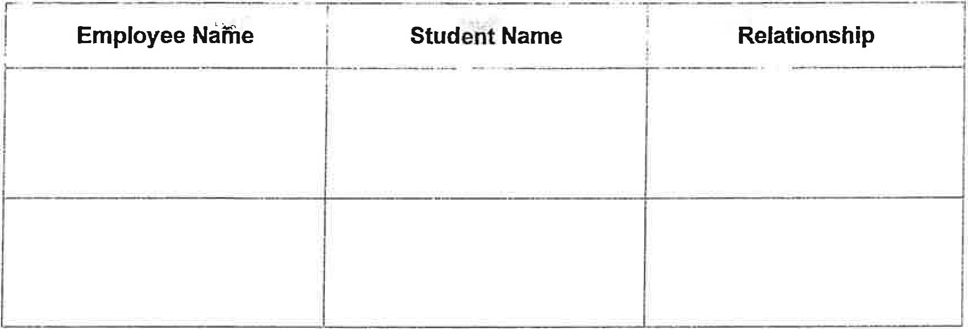
I can confirm that I am fully aware of the code of conduct relating to contact out of school with students in line with this policy.
If I am tutoring a student outside of school I am aware that the following must be adhered to:
- I do not, at any point, teach the child in question as part of my daily timetable this is a stipulation of such tutoring
- I emphasise to parents that this is done completely independently of the school.
- No monies come through the school at any point, informally (eg via the child) or formally.
No private tutoring is to take place on the school premises.
I confirm that if these circumstances change at any time I will complete a new form to ensure the school are aware of any relationships
Signed/Date:
Once completed, signed and dated, please return this form to the Principal.
Appendix 2

Confirmation of Compliance
I hereby confirm that I have read, understood and agree to comply with the school's code of conduct.
Name

Position/Post Held

Signed Date
Once completed, signed and dated, please return this form to the Principal.

Old Warren Primary School
ICT Code of Practice
- Pupils accessing the Internet should supervised by an adult at all times.
- All pupils are aware of the rules for the safe and effective use of the internet.
- Websites used by pupils should be checked beforehand by teachers where possible to ensure there is no unsuitable content and that material is age-appropriate.
- Deliberate/accidental access to inappropriate materials or any other breaches of the school code of practice should be reported immediately to the Principal/lCT coordinator.
- In the interests of system security, staff passwords are only shared with the network manager.
- Teachers are aware that the C2K and iPad system tracks all Internet use and records the sites visited. The system also logs emails and messages sent and received by individual users.
- Teachers should be aware of copyright and intellectual property rights and should be careful not to download or use any materials which are in breach of these.
- Photographs and videos taken by staff members are only for legitimate school use. Staff using smartphones to record images or video will delete images once legitimate purpose is achieved. Parents are asked to sign a consent document when their child is enrolled at the school, for images of their child to be recorded and displayed.
- The school Facebook account is managed by the ICT Co-ordinator and is regularly monitored for inappropriate use.
- School systems may not be used for unauthorised commercial transactions.

