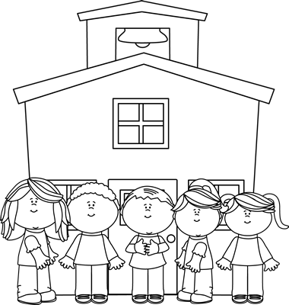
P1 Parent’s Newsletter – Autumn Term 1
This half term our topic will be:
All About Me
Please send in any recyclable materials for our junk modeling area e.g. toilet rolls, cardboard boxes, plastic tubs etc.
Please feel very welcome to speak to me if you have any concerns, by contacting the secretary.
I am looking forward to a fun-filled first term in Primary 1.
Mrs Jebb
- All children in Primary 1 will be receiving a healthy break each day at the small weekly cost of £3, which should be placed in your child’s individual snack wallet every Monday morning.
- Children are only allowed to drink water. They can leave their labelled water bottles in school and re-fill it each day using the water machine.

- Please ensure EVERY item of your child’s school uniform, coat, shoes and PE kit is clearly labeled.
- Children can come to school dressed in their PE uniform on Thursday.

In Numeracy we will be:
- Counting within 5 and 10.
- Creating and continuing patterns.
- Sorting objects by criteria.
- Investigating 2D shape – square, triangle, rectangle, circle.

In Literacy we will be:
- Beginning to form letters
- Writing sentences modeled by an adult
- Reading lots of books based around our topic.
- Introduced to characters and stories from our Oxford Reading Tree books.
In Phonics we will be:
- Taking part in listening activities
- Listening out for sounds in our environment
- Learning some initial sounds – s, a, t, p, i, n.

