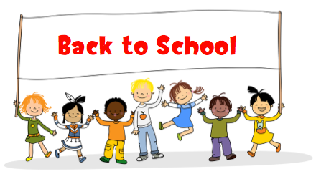

P3 Class News
Sept/Oct 2017

Topic Work

This half term our topic is ‘Colours and Materials’. We will investigate what happens when we mix certain colours together and we will be looking at the art work of Kandinsky and other artists and producing some of our own paintings and collages. We will investigate what everyday materials are used for and the different properties of those materials.

Numeracy

We will be doing lots of oral counting from 1 to 100, forwards and backwards from different starting numbers. We will be doing lots of work on numbers to 30, 50 and 100 using a 100 square, such as comparing the numbers, finding 1 more/1 less and 2more/2less than numbers to 100.We will be doing activities on understanding addition and subtraction, mental calculations, money and real life problems. We will also be learning about 2d and 3d shapes and patterns.

Literacy

In Literacy this term we will be looking at Stories with familiar settings, a non-fiction unit ‘Labels, lists and captions’ and poetry. We will be writing sentences properly using capital letters and full stops and beginning to add interesting words and details to our sentences.

Phonics
We will revise all the initial sounds learnt and then go on to recognise, read and write the sounds ‘ch’, ‘sh’, ‘th’, ‘ck’ and ‘ng’. In October we will begin to look at the ‘same sound, different spelling’.

Other Information

Please check your child’s schoolbag each night for homework/ notes.

Please ensure your child has their name on all uniform and their coat.

Children should keep their named PE kit in school at all times. I will send the PE kits home over the holidays to be washed.

On a Friday afternoon we have Golden Time as a reward for hard work and good behaviour during the week. On Thursdays we will discuss as a class what the children can or can’t bring in from home for that week’s Golden Time.

Healthy Eating There is a healthy eating policy in school and the snack you provide Monday- Thursday must be a healthy choice. Water is the only drink children are allowed in school, fizzy drinks are not permitted. Children are allowed to bring a small treat on Friday.
How can you help?

Reading
The most important thing you can do for your child this year is read with them for 10 minutes daily. Learning to read enables the children to read to learn. Discuss the book and point out keywords. Encourage your child to sound out new words using phonics. I would also encourage the sharing of stories and magazines at home as this gives the children a model on which to base their reading. P3 should be reading with a parent every night- please encourage this and record in the reading diary. Home reading books will be changed twice weekly. Please take good care of the books when they are in your home.

Number
Play math’s games with your child and allow them to help with practical activities such as measuring out ingredients when cooking and handling money. Please observe your child when they are writing numbers and make sure they are correctly formed and orientated. You can help your child at home by showing them when you use maths in real-life situations.

